**How to write a code snippet in the chapter?**

1. Please go to the link <https://highlightcode.com/> and you will find the following image:

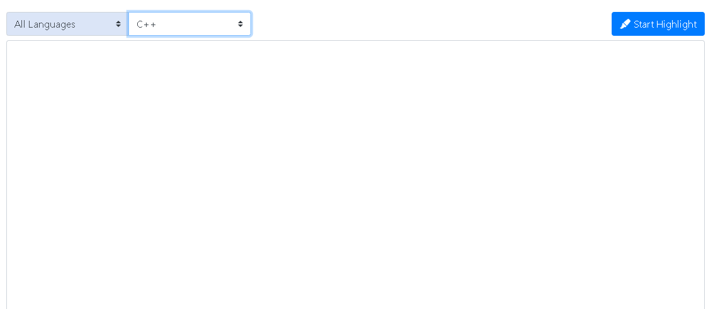

1. Copy the code and select the language syntax (for example: C/C++, Java, Python,) as per the requirement as shown in the following image:

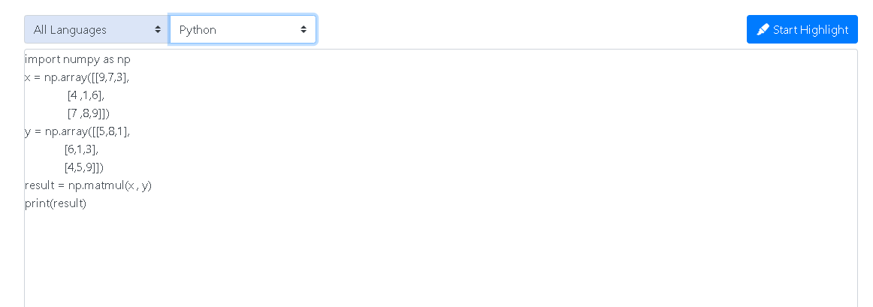

1. Once you click on Start highlighted on the right corner, it will generate a new web page and your code will be aligned as with steps as shown below.

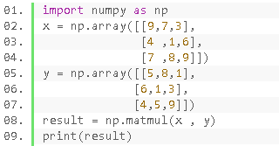

1. You would have to copy this output screen and paste it in the chapter for the required codes.

This format will help in differentiating the code from the content (context). Please follow this throughout the book.